Exercises Lecture 5 – Нестандартные виджеты и рисование

Aim: This exercise will take you through the process of creating custom widgets. You will try both composing a widget from existing components and implementing a new widget completely from scratch.
Duration: 1-1.5h

© 2010 Nokia Corporation and its Subsidiary(-ies).

The enclosed Qt Materials are provided under the Creative Commons Attribution-Non-Commercial-Share Alike 2.5 License Agreement.




The full license text is available here: http://creativecommons.org/licenses/by-nc-sa/2.5/legalcode.

Nokia, Qt and the Nokia and Qt logos are the registered trademarks of Nokia Corporation in Finland and other countries worldwide.

Составные виджеты
К упражнению прилагается архив с исходным кодом. Распакуйте содержимое этого архива перед началом работы. Первое упражнение основано на проекте filechooser.
Возьмём этот проект за основу. Он представляет собой простой пользовательский интерфейс для выбора имени файла. Если изменить размер окна, можно увидеть, что он никак не привязан с размером его содержимого. Все виджеты имеют фиксированное положение и размеры.

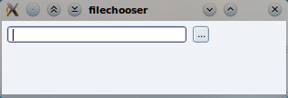
Вам предлагается исправить это недоразумение, создав и настроив горизонтальную компоновку для управления расположением и размерами находящихся в окне виджетов. Это нужно сделать в конструкторе класса FileChooser.
Сначала создайте объект QHBoxLayout, затем используйте функцию addWidget, чтобы добавить виджеты в эту компоновку в правильном порядке (слева направо).
В предложенном исходном коде с кнопкой не связано действий. Это неправильно, для начала найдите слот chooseFile(). Он будет использован для обработки нажатия пользователя на кнопку. В этом слоте запросите у пользователя путь к файлу, используя класс QFileDialog. После этого путь нужно записать в текст объекта lineEdit. Напишите код, чтобы происходило именно так. Самый простой подход — использовать функцию QFileDialog::getOpenFileName. Если пользователь отменяет выбор файла в диалоге QFileDialog, позаботьтесь об очистке содержимого lineEdit.

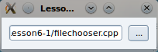
Чтобы запускать слот по нажатию кнопки, соедините сигнал clicked кнопки со слотом chooseFile в конструкторе класса FileChooser.

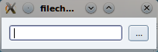
На данный момент, класс FileChooser уже можно использовать для выбора файла. Однако, добавив приведённые ниже функции с атрибутом доступа «public», этот класс можно будет использовать в других ситуациях.
QString file() const;
void setFile(const QString &file);
Напишите реализации этих двух функций, чтобы они возвращали и устанавливали значение текстовой строки. Тем самым, вы только что добавили публичный API для группы виджетов, из которых вы составили свой собственный виджет FileChooser. Каждый раз, когда вам нужно будет предоставить пользователю возможность выбора файла, вы сможете использовать готовый класс FileChooser.

Рисование рожицы
В оставшихся упражнениях вам нужно будет создать другой виджет – Smiley (рожица). Возьмём за основу проект smiley1.
На данный момент проект создаёт и показывает виджет рожицы, но результат — всего лишь пустое окно. Ваше задание — написовать рожицу в окне, реализовав функцию paintEvent(). Чтобы это сделать, вы напишете две вспомогательные функции: paintEye() и paintSmile(). Throughout the code in the smiley1 project, you will find connects that suggest appropriate size values to be used.
Найдите функцию paintEvent. В ней установите pen и brush для круга лица и используйте функцию Qpainter::drawEllipse, чтобы нарисовать круг с центром в точке center и радиусом size. Переменные size и center уже были вычислены.
QPen pen;
pen.setWidth(2);
pen.setColor(Qt::black);
painter.setPen(pen);
painter.setBrush(Qt::yellow);
painter.drawEllipse( …
When the face has been painted, continue by implementing the paintEye method. In it, again setup an appropriate pen and brush (yellow eyes do not look very healthy) and draw ellipses around the given center (pt) with the given size.
Finally, implement the paintSmile method. Setup a pen, then draw the smile using the QPainter::drawArc(QRect, int start, int length) method. Paint it from 0 degrees and make it 180 degrees wide. The length is specified in 16ths of a degree and in the wrong direction for our needs, to make sure to set the length to -180*16.
Running the application now should give you a window filled with a happy face!
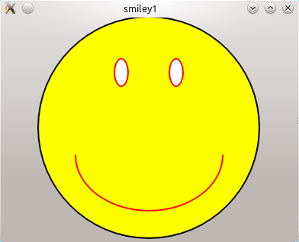

Handling Mouse Events
The next stage of the smiling widget project is to add eye movement tracking the mouse pointer while a mouse button is being pressed. The project is a continuation of the previous step, but there is support code that is added to it. The best way forward is to start from the smiley2 project.
The first thing that you need to do is to track the mouse position while a mouse button is being pressed. To do that, we use the QPoint variable called focusPoint. It holds the last known position of the mouse. For each of the event handles; mousePressEvent, mouseMoveEvent and mouseReleaseEvent, set the focus point to the current mouse location. You can get the mouse location from the QMouseEvent::pos() given.
Each time the position is changed, you need to tell Qt to redraw the widget. You do this by calling the QWidget::update() method. This should give you a smiley with mouse tracking eye movements.

Adding signals and slots
The final step in creating your own widget is about signals and slots. Usually, you connect the right signal to the right slot, but when creating custom widgets you must also provide the right signals and slots.
Again, this is a continuation from the previous step, but with added support code. This means that you should start from the smiley3 project provided in the source code package.
The goal of this step is to modify the Smiley class so that the extent of the smile can be adjusted using signals and slots. This means that when incorporating the smiley widget in a user interface, the smile can be adjusted in a reusable way.
The first point of change is the paintSmile() method. It needs to be modified to accept an angle which will determine the starting angle and arc span for painting. The size of the smile is stored in the m_smileSize variable.
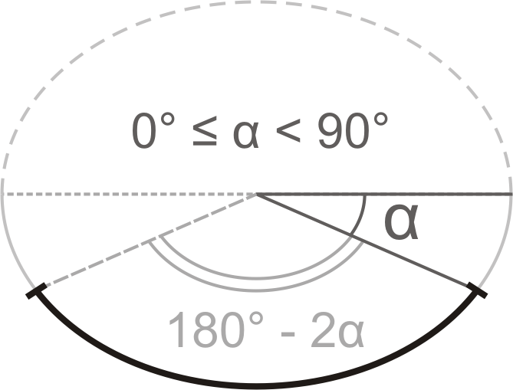
Implement the paintSmile() method so that it follows the figure above, where the argument angle corresponds to alpha. You can test your implementation by changing the value of m_smileSize in the class constructor. Valid values for the value are 0-100.
The next step is to expose an appropriate API for modifying the size of the smile. The size of the smile is kept in the m_smileSize variable and is measured as percentage of the full smile (so its values in range 0-100).
To indicate that the class has custom signals and slots, start by adding the Q_OBJECT macro at the top of the class implementation. Having done this, you have to re-run the qmake command on the project. In Qt Creator, you do this by right clicking on the project and selecting the Run qmake in... option
The first API function to implement is the public setSmileSize() slot. Make sure that only valid values are accepted. When implemented, you can test your slot by dragging the slider under the smiley in the window. As the slot alters the m_smileSize variable, which in turn affects the appearance of the widget, make sure to call update in the slot as well.
When providing a slot for altering a member variable, it is common practice to extend the class with a corresponding reading function (already present in the smiley3 project) and a signal emitted when the value is changed.
First add code to emit the signal smileSizeChanged(int) whenever the smile size changes. Start by declaring the signal in the class header, then modify the setSmileSize slot to emit the signal. Make sure that the signal only is emitted when the value is changed, not when it is set to the same value as it already was.
To take the smile size from a set of methods and a private variable to a Qt property, you need to declare it as such.You can do that by adding the following line right after the Q_OBJECT macro in the Smiley class declaration.
Q_PROPERTY(int smileSize READ smileSize WRITE setSmileSize)
This informs Qt there is a smileSize property of type int that can be accessed using smileSize and setSmileSize methods. This makes it possible to integrate the widget with Qt Designer, as well as accessing the property using the Qt meta-object interfaces.

Solution Tips

Step 1
If you pass this to the constructor of the layout object, the layout will handle the layout of the current widget.
QHBoxLayout *layout = new QHBoxLayout(this);
layout->addWidget(lineEdit);
layout->addWidget(button);
Use QFileDialog::getOpenFileName() to query the user for a file name.
QString path = QFileDialog::getOpenFileName(this);
Use the setText method to update the line edit.
lineEdit->setText(path);
Use QObject::connect method to set up a connection between the button's clicked() signal and chooseFile() slot of the main widget.
connect(button, SIGNAL(clicked()), this, SLOT(chooseFile()));
The file and setFile methods are used to access the text property of the lineEdit. This makes them very simple to implement.
QString FileChooser::file() const
{
return lineEdit->text();
}

void FileChooser::setFile(const QString &file)
{
lineEdit->setText(file);
}

Step 2
Draw the face with QPainter::drawEllipse() passing it the center of the circle and its radius.
painter.drawEllipse(center, size/2, size/2);
Use similar code for the eyes. Make the eye width half the size of its height.
painter->drawEllipse(pt, size/4, size/2);
The smile can be drawn as an arc by calling QPainter::drawArc(). Make it draw from the right, downwards and to the left with a total of 180 degrees span. The angles are passed in 1/16th of degree and counted clock-wise (pass negative values for counter-clockwise direction).
painter->drawArc(r, 0, -180*16);

Step 3
To store the current position of the cursor, assign the point retrieved from the mouse event to a member variable.
focusPoint = me->pos();
If you want an indifferent look when the mouse button is released, you can assign an empty (invalid) point to the focusPoint.
void Smiley::mouseReleaseEvent(QMouseEvent *) {
focusPoint = QPoint();
update();
}

Step 4
To make sure the value passed to the slot is within appropriate range you can use qBound() macro passing it the minimum, current and maximum values. It will return the current value bounded to the minimum-maximum range.
size = qBound(0, size, 100);
Check that you only emit a signal when the smile size changes. You can simply return from the method upon detecting that no change occurs.
if(size == m_smileSize)
return;
m_smileSize = size;
emit smileSizeChanged(size);

